Code Smells -Martim Costa 64901

Location: \ganttproject\src\main\java\net\sourceforge\ganttproject\application\MainApplication

This function has a large size (around 88 lines), making it difficult and exhausting to understand the processes that are happening.

My suggestion to improve and refactor this code is to create smaller methods to decrease the size of this function, turning it easier to read and debug.

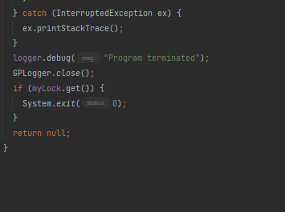

Location: \ganttproject\src\main\java\biz\ganttproject\impex\csv\GanttCVSExport

This class has variables with excessively long identifiers, making harder to read and use.

My suggestion is to reduce the size of the identifiers, using naming conventions of software architecture, reducing the effort to read and understand the code, and enable code reviews to have more focus on more important issues than naming and syntax standards.

One example could be deleting the “Human” and using only a “H” and then comment above what the “H” means. 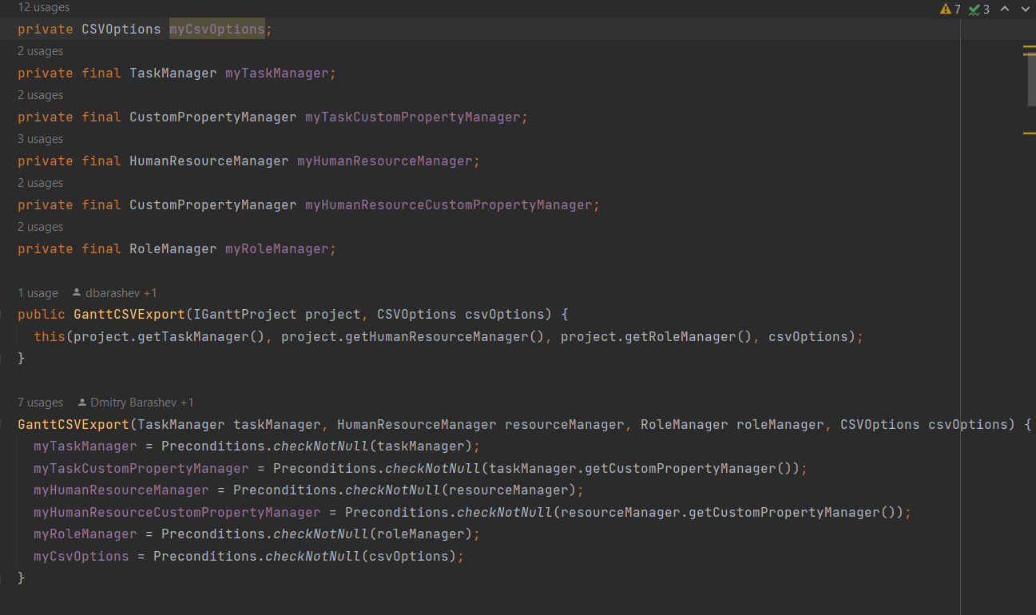

Location: ganttproject\src\main\java\net\sourceforge\ganttproject\GanttGraphicArea

This constructor has to many arguments (10), making it hard to debug, and probably meaning that this Class is doing more than it should.

One possible way to improve this is to define a class which holds these parameter values and re-phrase the constructor to accept the class instance as a parameter instead of individually requesting the parameters.

